Dear (Your School Name) High School of Business™ Student,
Congratulations on completing (HSB Course Name)!
Did you know you are part of a national program of students achieving their goals of pursuing a career or a college degree in business?

What’s the big deal?
There are many benefits to being part of High School of Business and even more benefits to completing all the courses. Talk to your teacher or school counselor to find out which course(s) to take next. We want you to get all the benefits—like the following:
- Free Money… in the form of College Credit: 9.5 credits on average; up to 22 credits at some schools
- Meet Some Big Shots – Meet and get to know business owners and professionals in your hometown
- Win Big – BPA, DECA, FBLA: HSB students rank high in competitive student organization events
- Have Fun and Make New Friends – Work in groups to get hands-on experience with real projects
- Be Your Own Boss – Design, start, and operate a business with your class in senior year
- Slay Your Fears of Public Speaking – HSB students give up to 20 presentations
- Rock Your College Application – Enter college with more business knowledge and project management skills than your peers. Brag about your business smarts on your applications!
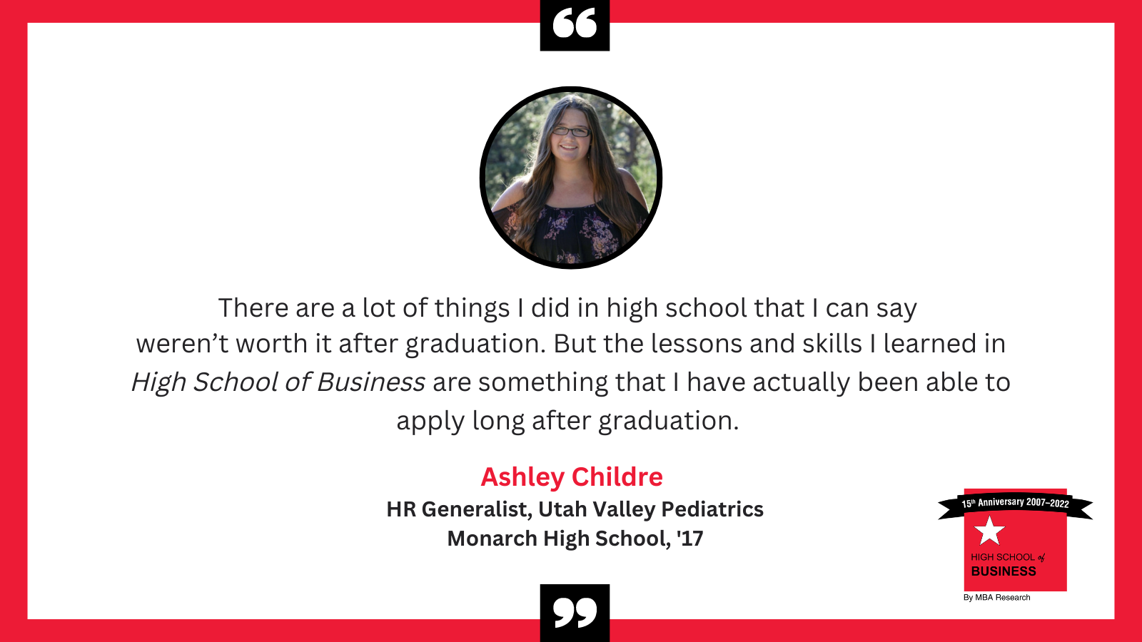

You are part of a national program!
Curious what students across the country are doing in their schools? HSB News is full of articles about real students, just like you, doing great things at their schools and in their hometowns. Learn first-hand from HSB alumni about how HSB prepared them for their future—in college, in career, and beyond!
If you complete the full program of courses, you can list this accomplishment on your LinkedIn profile, or on college applications. HSB digital badges explain everything to future employers or college admissions teams, including our organization’s mission to help students like you.
Wishing you the best in your high school journey—we know this is just the beginning of the great things you’ll do!

Laurie Urich
Program Director, High School of Business™
MBA Research and Curriculum Center

Zulfa Rizqiya
Program Administrator, High School of Business™
MBA Research and Curriculum Center

