Guide to the National Business Administration Standards
Business-Related Clusters

MBA Research focuses its research, curriculum and instructional-materials design, and assessment activities on three distinct business-related clusters:
- Business Management: Careers in the Business Management Cluster are dedicated to performing administrative and managerial processes vital to the success and ongoing existence of a business organization, regardless of the sector or industry in which the business resides or the product/service it provides.
- Finance: The Finance Cluster includes career opportunities related to making strategic decisions to report, obtain, save, protect, and grow the financial assets of businesses and/or individuals.
- Marketing: The Marketing Cluster includes career opportunities whose processes create, communicate, and deliver value to customers and manage customer relationships in ways that benefit the organization and its stakeholders.
Pathways

Each of these three clusters is composed of a number of pathways whose content represents a variety of broad-based occupational opportunities that have similar skillset requirements. To be considered a pathway, the following must exist: a discrete, core body of knowledge; well-defined career ladder; professional certification and training; professional associations; and critical mass in terms of number of jobs.

Pathways for the Business Management Cluster are:
- Administrative Services
- Business Information Management
- General Management
- Human Resources Management
- Operations Management

The pathways for the Finance Cluster are:
- Accounting
- Banking Services
- Corporate Finance
- Insurance
- Securities and Investments

Pathways for the Marketing Cluster are:
- Marketing Communications
- Marketing Management
- Marketing Research
- Merchandising
- Professional Selling

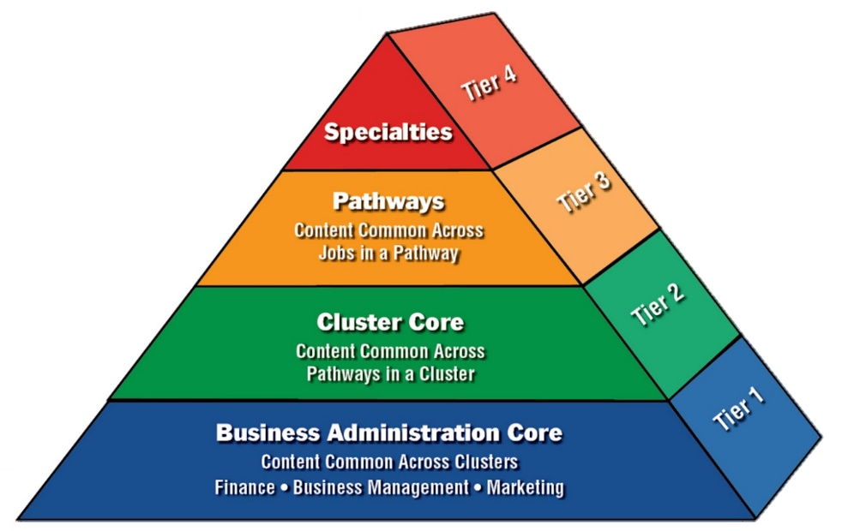
Levels of Specificity
The National Business Administration Standards, which encompass the three business-related clusters of Business Management, Finance, and Marketing, consist of four tiers of specificity: Business Administration Core, Cluster Core, Pathways, and Specialties. The content of the broad-based Business Administration Core is fundamental to an understanding of business in all three of these clusters and can be viewed as co-requisites and as prerequisites for all business administration courses.
Business Administration Core
The Business Administration Core represents skills and knowledge needed for success in careers in all three-business related clusters and therefore should be addressed in all Business Management, Finance, and Marketing programs. Content in the Business Administration Core must be mastered in order for cluster-specific content to have relevance to student learning. There are 13 Business Administration instructional areas: Business Law, Communication Skills, Customer Relations, Economics, Emotional Intelligence, Entrepreneurship, Financial Analysis, HR Management, Information Management, Marketing, Operations, Professional Development, and Strategic Management.
Cluster Core
The Cluster Core tier represents the skills and knowledge identified as common across the Pathways in a particular cluster. The Finance Cluster Core, for example, is composed of six instructional areas: Compliance, Customer Relations, Financial Analysis, Financial-Information Management, Professional Development, and Risk Management.
Pathways
The Pathways tier addresses the content of a variety of broad-based occupational opportunities within a cluster. In the Business Management Cluster, for instance, the skills and knowledge that are common across jobs in operations management appear in the Operations Management Pathway.
Specialties
The fourth tier, Specialties, focuses on specific job opportunities that are tied to a pathway. The job opportunities identified in the Specialties require knowledge and skills unique to a product or service. In Marketing, as an example, Specialties for the Professional Selling Pathway include pharmaceutical sales, advertising sales, heavy-equipment sales, and medical-equipment sales.
Thus, the business administration curriculum can be viewed as a continuum that begins in the primary grades with career awareness and exploration and continues through postsecondary education with the emphasis becoming more specialized to the learner’s individual interest in business.

Curricular Organization
Within each tier of the pyramid, the curricular content has been organized into Standards/Instructional Areas (Knowledge and Skill Statements), Performance Elements, and Performance Indicators.
Standards/Instructional Areas
The broadly-based Standards/Instructional Areas identify what students should know and be able to do as a result of instruction in any of the business-related clusters. These statements encapsulate the overarching intent/purpose of a work function. The Economics Standard identified in the Business Administration Core, for example, is: “Understands the economic principles and concepts fundamental to business operations.” Each Standard/Instructional Area represents a particular topic—not a course.
Performance Elements
Each Standard is composed of multiple Performance Elements. These statements are broad-based work or cognitive performances that aid in defining the Standards. A Performance Element from the Economics Instructional Area, for instance, is “Understand the nature of business to show its contributions to society.”
Performance Indicators
Performance Elements are defined through Performance Indicators that are specific work-based actions—either knowledge or skills. They specify what an individual worker must know or be able to do to achieve the Performance Elements. These learning outcomes are measureable (i.e., can be assessed). For example, one of the eight Performance Indicators for the Economics Performance Element “Understand the nature of business to show its contributions to society” is: “EC:070 Explain the role of business in society.”
Objectives
Each of the Performance Indicators is further defined through a series of Objectives. This organizational component specifies the scope of each Performance Indicator. Their use tells teachers what content to include or exclude from their instruction. For example, the Performance Indicator “Describe the concepts of economics and economic activities” is defined through Objectives as follows:
- Define the following terms: economics, scarcity, economizing, opportunity cost, trade-offs, consumption, consumer, production, producer, exchange, and distribution.
- Explain why wants are considered unlimited.
- Discuss why scarcity exists.
- Describe the three economic questions that all societies must answer.
- Explain the importance of decision making in economics.
- Describe four economic activities.
- Discuss three factors that affect the value of money payments in a market economy.

Curriculum Planning Levels
Each performance indicator is assigned to one of six curriculum-planning levels that represent a continuum of instruction ranging from simple to complex. The levels can serve as building blocks for curriculum development in that students should know and be able to perform the performance indicators at one level before tackling more complex skills and knowledge at the next level. The six curriculum-planning levels are described as follows:
Prerequisite (PQ):
- Content develops employability and job-survival skills and concepts, including work ethics, personal appearance, and general business behavior
- Appropriate for 9th-11th graders, students with little/no business background, and students with special needs
Career Sustaining (CS):
- Content develops skills and knowledge needed for continued employment in or study of business based on the application of basic academics and business skills
- Appropriate for “typical” high-school students of average and above-average abilities and interest
Specialist (SP):
- Content provides in-depth, solid understanding and skill development in all business functions
- Appropriate for advanced high school students and post-secondary students
Supervisor (SU):
- Content provides the same in-depth, solid understanding and skill development in all business functions as in the specialist curriculum, and in addition, incorporates content that addresses the supervision of people
- Appropriate for young adults at post-secondary level
Manager (MN):
- Content develops strategic decision-making skills in all business functions needed to manage a business or department within an organization
- Appropriate for young adults at post-secondary level
Owner (ON):
- Content develops strategic decision-making skills in all aspects of business that are needed to own and operate a business
- Appropriate for young adults at post-secondary level

Deciphering the Code
Each performance indicator statement is preceded by—as well as followed by—multiple codes, as in the following example:
EC:070 Explain the role of business in society (CS) LAP-EC-070
Performance Indicator Number/Code
The code immediately preceding the performance indicator statement is the statement’s performance indicator number or code (in this example, EC:070). The performance indicator code is somewhat akin to a person’s social security number—a unique identifier used as shorthand for the longer full statement. MBA Research uses performance indicator codes most frequently to pull test questions from its test-item database. Performance indicator codes are often referenced on tests and in MBA Research’s curricular and instructional materials. The alpha-numeric performance indicator code consists of:
- A two-letter abbreviation for the instructional area in which the performance indicator appears (e.g., EC, which stands for the Economics instructional area)
- A random three-digit numeral (e.g., :070)
Curriculum Planning Level Code
Every performance indicator statement is followed by a two-letter code in parentheses. This code identifies the curriculum-planning level to which the performance indicator has been assigned. In our example, that code is CS, which means that this performance indicator is at the Career Sustaining level. (See Curriculum Planning Levels on page 3 for more information.)
LAP Number/Code
Many performance indicators are also followed by a code beginning with LAP (short for Learning Activity Package), which indicates that MBA Research has developed a lesson module for that particular performance indicator. The LAP number or code (e.g., LAP-EC-070) references the two-letter abbreviation for the instructional area, along with a three-digit number. Historically, the three-digit number in the LAP code indicated the order in which the LAPs for a particular instructional area were developed. MBA Research is currently transitioning, however, to a LAP numbering system in which the number appearing in the LAP code is the same as the number in the performance indicator code.

